NAME – NIKITA BISHT

COURSE – BCA 5B

ROLL NO – 13

UNIVERSITY ROLL NO – 1121093

**PROBLEM STATEMENT - 8:**Write a HTML code to create a hyperlink from top of your page to the bottom of the same page.

**OBJECTIVE :** To understand the concept of linking page from top to bottom.

**HTML CODE:**

<html>

<style>

.style

{

background-color:white;

}

</style>

<head><title>SOME BOLLYWOOD STARS</title></head>

<body style="background-color:grey;background:rgba(0,0,255,0.3)">

<a id="sec"href="#down">...</a>

<center>

<section class="style">

<h1 style="background:blue;">SOME BOLLYWOOD STARS OF INDIA</h1>

<b style="color:brown;font-size:20;background:lightgreen;">POPULAR BOLLYWOOD STARS OF INDIA </b>

</section><br>

</center>

<section class="style">

<image src="https://pbs.twimg.com/media/DRulULhV4AEz7t1.jpg" alt="image" align="right">

<BR CLEAR="left"/>

<h1>

Hindi cinema, often known as Bollywood and formerly as Bombay cinema, is the Indian Hindi-language film industry based in Mumbai (formerly Bombay). The term is a portmanteau of "Bombay" and "Hollywood". The industry is related to Cinema of South India and other Indian film industries, making up Indian Cinema—the world's largest by number of feature films produced.

In 2017, Indian cinema produced 1,986 feature films, with Bollywood as its largest filmmaker, producing 364 Hindi films the same year. Bollywood represents 43 percent of Indian net box-office revenue; Tamil and Telugu cinema represent 36 percent, and the remaining regional cinema constituted 21 percent in 2014. Bollywood is one of the largest centres of film production in the world. In 2001 ticket sales, Indian cinema (including Bollywood) reportedly sold an estimated 3.6 billion tickets worldwide, compared to Hollywood's 2.6 billion tickets sold. Bollywood films tend to use vernacular Hindustani, mutually intelligible by people who self-identify as speaking either Hindi or Urdu, and modern Bollywood movies increasingly incorporate elements of Hinglish.

The most popular commercial genre in Bollywood since the 1970s has been the masala film, which freely mixes different genres including action, comedy, romance, drama and melodrama along with musical numbers. Masala films generally fall under the musical film genre, of which Indian cinema has been the largest producer since the 1960s when it exceeded the American film industry's total musical output after musical films declined in the West; the first Indian musical talkie was AlamAra (1931), several years after the first Hollywood musical talkie The Jazz Singer (1927). Alongside commercial masala films, a distinctive genre of art films known as parallel cinema has also existed, presenting realistic content and avoidance of musical numbers. In more recent years, the distinction between commercial masala and parallel cinema has been gradually blurring, with an increasing number of mainstream films adopting the conventions which were once strictly associated with parallel cinema.

</h1><br></br>

</section>

<table style="width:50%;">

<tr>

<th><image src="https://m.hindustantimes.com/rf/image_size_640x362/HT/p1/2014/11/04/Incoming/Pictures/1282349_Wallpaper2.jpg" height="250"></th>

<th><image src="https://imagevars.gulfnews.com/2019/01/31/TAB_190131-Kangana-Ranaut-1548920556294_16a3107b5d6_large.jpg" height="250"></th><br>

</tr>

<tr>

<td><nav class="style"><b><center>DeepikaPadukone<br>occupation -film actress and producer <b><br>age -<b> 34<br>

<b>No. of movies- 82</b><br><b>height-</b> 1.74m <br><b>born date- </b>5 jan 1986 <br><b>hometown-<b>bangalore, India <br><b>awards- <b>15</center></b>

<a style="background:maroon;color:white;padding:0px 10px;"id="p1"href="#b1">profile</a></nav>

</td>

<td><nav class="style"><b><center>KanganaRanaut<br>occupation -film actress and filmmaker <b><br>age -</b> 33<br>

<b>No. of movies- 35</b><br><b>height-</b> 1.66m <br><b>born date- </b>23 march 1987 <br>hometown- Himachal Pradesh ,<b>India<br><b>awards- <b>12</center></b>

<a style="background:maroon;color:white;padding:0px 10px;"id="p1"href="#b1">profile</a></nav>

</td>

</h1><br></br>

</section>

<table style="width:100%;">

<tr>

<th><image src="https://static.toiimg.com/photo/msid-76461834/76461834.jpg?201380" height="250"></th>

<th><image src="https://cdn.dnaindia.com/sites/default/files/styles/full/public/2017/11/30/628887-rajkummar-rao.jpg" height="250"></th>

<th><image src="https://upload.wikimedia.org/wikipedia/commons/b/b3/Tiger_Shroff_in_2019.jpg" height="250"></th>

<th><image src="https://i.pinimg.com/originals/32/39/03/323903e09fc84dc7e337edf8c209149a.jpg " width="200" height="250"></th><br>

</tr>

<tr>

<br><td><nav class="style"><b><center>Kritisanon<br>occupation -film actress <b><br>age -<b> 30<br>

<b>No. of movies- 16</b><br><b>height-</b> 1.73m <br><b>born date- </b>27 july 1990 <br><b>hometown-<b> New Delhi, India <br><b>awards- <b>3</center></b>

<a style="background:maroon;color:white;padding:0px 10px;"id="p1"href="#b1">profile</a></nav>

<td><nav class="style"><b><center>RajKummarRao<br>occupation -film actor <b><br>age -</b> 36<br>

<b>No. of movies- </b> 35 <br><b>height-</b> 1.7m <br><b>born date- </b>31 august 1984 <br>hometown- gurugram,<b>haryana,<b>India<br><b>awards- <b>5</center></b>

<a style="background:maroon;color:white;padding:0px 10px;"id="p1"href="#b1">profile</a></nav>

<td><nav class="style"><b><center>Tiger Shroff<br>occupation -film actor and material artist <b><br>age -</b> 30<br>

<b>No. of movies- </b> 8 <br><b>height-</b> 1.75m <br><b>born date- </b>2 march 1990 <br>hometown- Mumbai ,<b>India<br><b>awards- <b> 1</center></b>

<a style="background:maroon;color:white;padding:0px 10px;"id="p1"href="#b1">profile</a></nav>

<td><nav class="style"><b><center>DishaPatani<br>occupation -film actor <b><br>age -</b> 28<br>

<b>No. of movies- </b> 10 <br><b>height-</b> 1.70m <br><b>born date- </b>13 june 1992 <br>hometown- gurugram,<b>Bareilly,<b>India<br><b>awards- <b>5</center></b>

<a style="background:maroon;color:white;padding:0px 10px;"id="p1"href="#b1">profile</a></nav>

</td>

<nav></td>

</tr>

<table style="width:100%;">

<tr>

<th><image src="https://static.toiimg.com/photo/65675521.cms" height="250"></th>

<th><image src="https://static.toiimg.com/thumb/msid-77850697,width-800,height-600,resizemode-75,imgsize-613360/77850697.jpg" height="250"></th>

<th><image src="https://imagevars.gulfnews.com/2020/01/17/Kajol-1579251170192_16fb2b47b91_large.jpg" height="250"></th>

<th><image src="https://encrypted-tbn0.gstatic.com/images?q=tbn%3AANd9GcR_eryt81JV7X5CFqy0fcdqSHkhKvAYq5LDAA&usqp=CAU" height="250"></th>

</tr>

<tr>

<td><nav class="style"><b><center>Ranveer Singh<br>occupation -film actor <b><br>age -</b> 35<br>

<b>No. of movies- </b> 17 <br><b>height-</b> 1.78m <br><b>born date- </b>6 july 1985 <br>hometown- Bombay,<b>India<br><b>awards- <b>4</center></b>

<a style="background:maroon;color:white;padding:0px 10px;"id="p1"href="#b1">profile</a></nav>

<td><nav class="style"><b><center>Vicky Kaushal<br>occupation -film actor <b><br>age -</b> 32<br>

<b>No. of movies- </b> 13 <br><b>height-</b> 1.83m <br><b>born date- </b>16 may 1988 <br>hometown- <b>Mumbai,<b>India<br><b>awards- <b>2</center></b>

<a style="background:maroon;color:white;padding:0px 10px;"id="p1"href="#b1">profile</a></nav>

<td><nav class="style"><b><center>Kajol<br>occupation -film actress <b><br>age -</b> 46<br>

<b>No. of movies- </b> 39 <br><b>height-</b> 1.6m <br><b>born date- </b>5 august 1974 <br>hometown- <b>Mumbai,<b>India<br><b>awards- <b>6</center></b>

<a style="background:maroon;color:white;padding:0px 10px;"id="p1"href="#b1">profile</a></nav>

<td><nav class="style"><b><center>RaniMukherjee<br>occupation -film actress <b><br>age -</b> 42<br>

<b>No. of movies- </b> 50 <br><b>height-</b> 1.56m <br><b>born date- </b>21 march 1978 <br>hometown- Kolkata,<b>India<br><b>awards- <b>5</center></b>

<a style="background:maroon;color:white;padding:0px 10px;"id="p1"href="#b1">profile</a></nav>

</tr>

</table>

<center>

<article class="style" style="width:100%;"><br></br>

<a style="background:maroon;color:white;padding: 0px 10px;font-size:30;"id="b1"href="#p1">back</a><br>

<image style="padding:0px 0px;" src="https://images.inuth.com/2017/10/1Deepika-Padukone-at-the-launch-of-Hema-Malinis-biography.jpg" height="450">

<pre style="font-size:16;"><b>DEEPIKA PADUKONE<br>FILM ACTRESS AND PRODUCER | Age:</b> 34

<a style="font-family:arial;font-size:10;">

DeepikaPadukone is an Indian actress and a former model. Padukone made her acting debut with the 2006 Kannada film Aishwarya.

The following year, she made her Hindi film debut with the blockbuster Om Shanti Om which earned her the Filmfare Best Female Debut Award.

Padukone was born in Copenhagen, Denmark. Her family moved to Bangalore, India, when she was eleven months old.

Padukone is of Mangalorean origin, and her mother tongue is Konkani.

Her lineage hails from Padukone village in KundapuraTaluk in the Udupi District of the state of Karnataka, India.

Her father, PrakashPadukone, is a retired badminton player of international repute, and her mother is a travel agent.

Padukone also has a younger sister, Anisha, born on February 2, 1991.

Padukone attended Sophia High School in Bangalore, and completed her pre-university studies at Mount Carmel College in Bangalore.

While in high school she played badminton at the state level. However, she was not keen on pursuing a career as a badminton player.

Modelling:

While in college, Padukone pursued a career in modelling. She was spotted in a ramp competition in NLS, Bangalore.

Over the years, she has modelled for such Indian brand names as Liril, DaburLal powder, Close-Up toothpaste and Limca, and has been the "brand ambassador" for the Jewels of India retail jewellery show.

The cosmetics company Maybelline made her its international spokesperson.

At the fifth annual Kingfisher Fashion Awards she was awarded the title "Model of the Year".

Shortly afterward, she was chosen as one of the models for the Kingfisher Swimsuit Calendar for 2006 and won two trophies at the Idea Zee Fashion Awards: "Female Model of the Year - (Commercial Assignments)" and "Fresh Face of the Year".

Padukone was also chosen as the brand ambassador of Kingfisher Airlines and later Levi Strauss and Tissot SA.

Acting:

Deepika got her formal acting training from the AnupamKher School of Acting where she was one of the most dedicated students.

After pursuing a successful career in modelling, Padukone branched out into acting.

She started by starring in the music video for the song NaamHaiTera from the independent pop album AapKaaSurroor by HimeshReshammiya.

In 2006, Padukone made her cinematic debut in the Kannada film Aishwarya starring opposite actor Upendra.

She later made a successful Bollywood debut in 2007 with Farah Khan's international hit Om Shanti Om opposite Shahrukh Khan.

Her performance was well received, earning the actress a Filmfare Best Female Debut Award as well as her first Filmfare Best Actress nomination.

TaranAdarsh from indiaFM noted, "Deepika has all it takes to be a top star — the personality, the looks and yes, she's supremely talented too.

Standing in the same frame as SRK and getting it right is no small achievement. She comes as a whiff of fresh air!"

Padukone was then seen in SiddharthAnand's romantic comedy BachnaAeHaseeno opposite RanbirKapoor and alongside BipashaBasu and MinisshaLamba.

The film, which released on 15 August 2008, performed reasonably well at the box office.

Her next film ChandniChowkTo China, released on 16 January 2009, and was a critical and commercial disaster.

Padukone's fourth release Love AajKal, released on 31 July 2009 and proved to be one of the biggest hits of 2009.

Padukone was next seen in Excel Entertainment’s Karthik Calling Karthik opposite FarhanAkhtar, which released on 26 February 2009.

He also acted in Sajid Khan’s Housefull alongside Akshay Kumar, in Khelein Hum JeeJaanSey directed by AshutoshGowarikar, and in KunalKohli’s Break KeBaad co-starring Imran Khan.

In 2009, Deepika started writing weekly columns for HT City, the lifestyle supplement of Hindustan Times.

These columns appear online on social network, Desimartini.

</a>

<br></br>

<a style="background:maroon;color:white;padding:0px 10px;"id="b2"href="#p2">back</a><br>

<image src="https://www.iwmbuzz.com/wp-content/uploads/2019/06/controversial-statements-by-kangana-ranaut-that-define-her-2-920x518.jpg" height="450"><br>

<pre style="font-size:25;">

<b>KanganaRanut

<b>film Actress | Age:</b>33

<a style="font-family:arial;font-size:8;">

KanganaRanaut is an Indian film actress, who worked predominantly in Bollywood and is one of the highest-paid actresses in India.

She was born on 23 March 1986 at Bhambla, a small town in the Mandi district of Himachal Pradesh, into a Rajput family.

She completed her schooling from DAV model school Sector 15 in Chandigarh. She later joined Government Art College for pursuing her higher studies.

Career

Kangana started her career from theatre in Delhi with Asmita Theatre Group.

Arvind Gaur trained her who was a theatre director. She played her first play with Arvind Gaur named Taledanda.

Then Ranaut joined Asha Chandra's course in 2004 to get ready for Bollywood. After that she came to Mumbai to try her luck in movies.

In September 2005, AnuragBasu saw her at a cafe in Mumbai, and offered her the lead role for his movie Gangster.

It became a success at the box office. Then she did a film WohLamhe.

She then starred in films Life In A Metro, Shakalaka Boom Boom in the year 2007. Next, in the year 2008, she starred in the film Fashion, which gave her the Filmfare Best Supporting Actress Award and National Film Award for Best Supporting Actress.

Ranaut lives in Mumbai with her sister Rangoli, who was the victim of an acid attack in 2006. She makes yearly visits to her hometown of Bhambla.

A practicing Hindu, Ranaut follows the teachings of the spiritual leader Swami Vivekananda and considers meditation to be "the highest form of worshipping God".

She practices vegetarianism and was listed as "India's hottest vegetarian" in a poll conducted by PETA in 2013. Since 2009, Ranaut has been studying the dance form of Kathak from the NateshwarNritya Kala Mandir.

She has said that the technical process of filmmaking is of tremendous interest to her, and to better her understanding of it Ranaut enrolled in a two-month screenplay writing course at the New York Film Academy in 2014.

In an interview with Filmfare she said that despite her stardom, she wants to lead a normal life: "I don't want to lose my rights as a common person to learn and grow".

</a>

</article>

</center>

<a href="#sec"id="down">ugh</a><br></br>

</body>

</html>

OUTPUT:

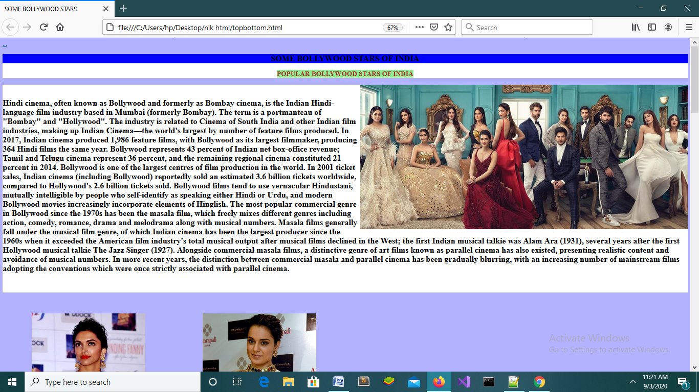

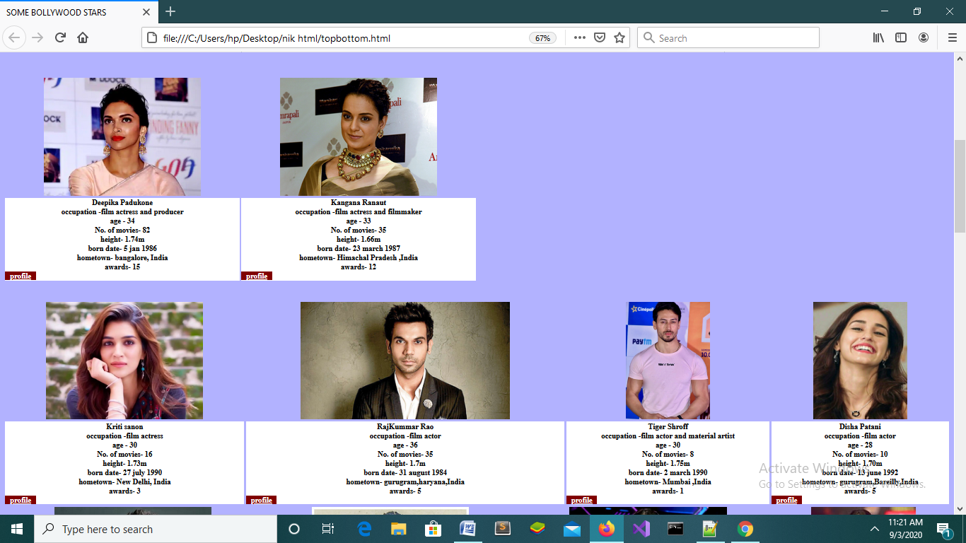

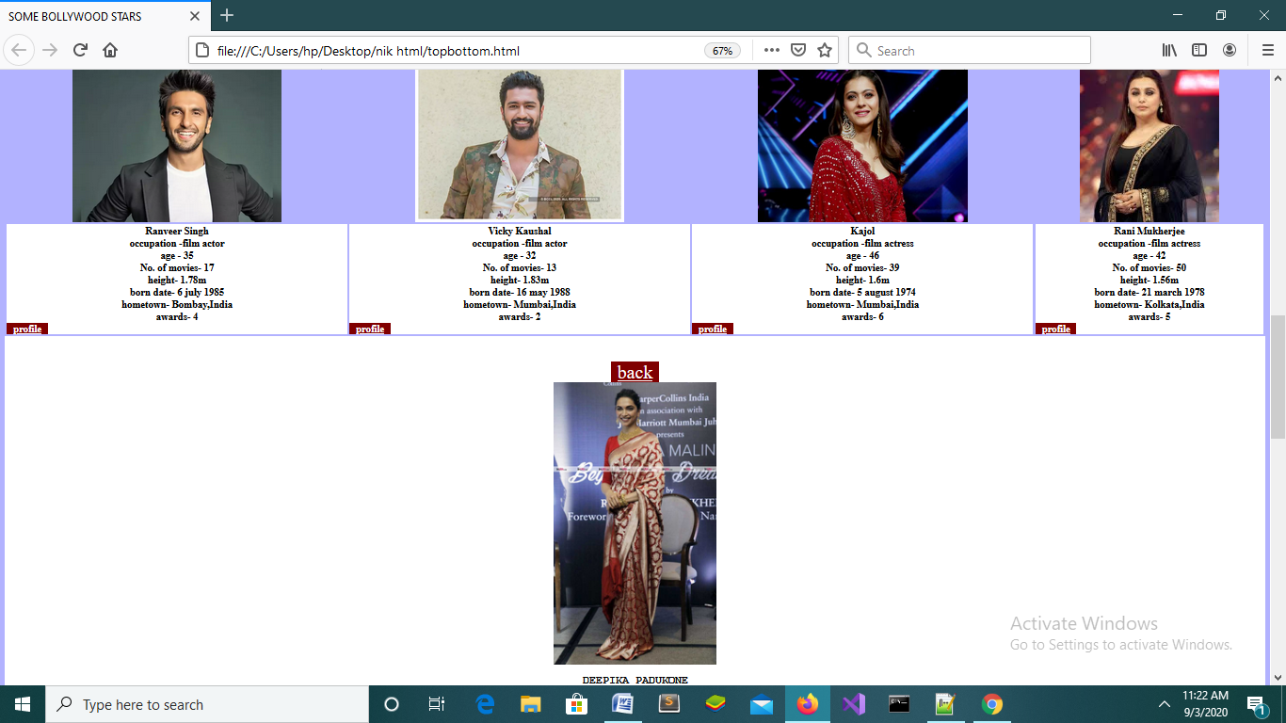

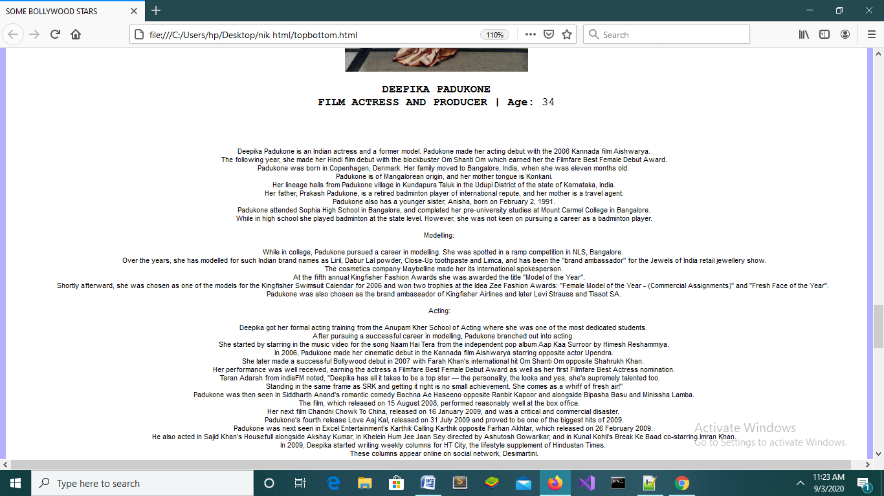

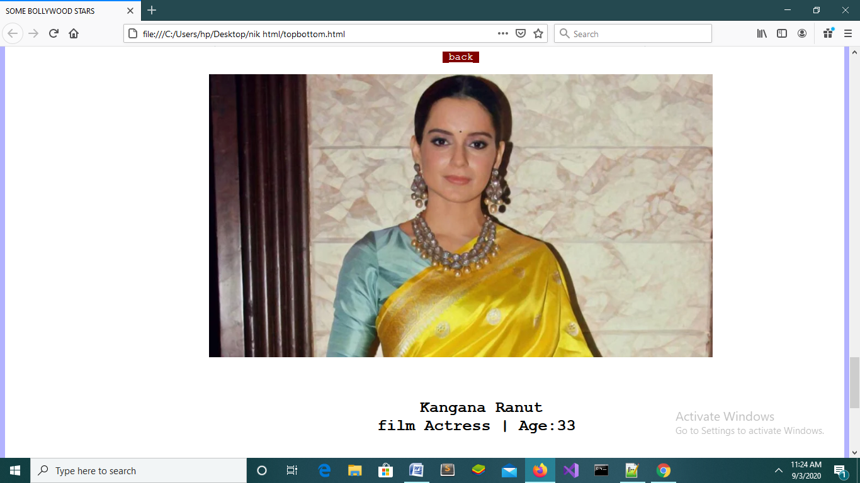

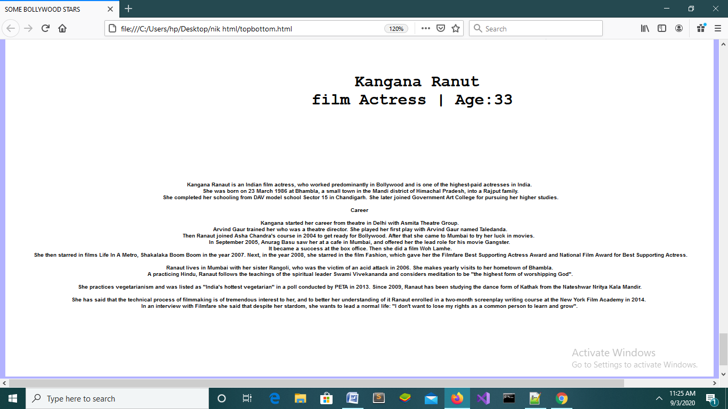

NAME – NIKITA BISHT

COURSE – BCA 5B

ROLL NO – 13

UNIVERSITY ROLL NO – 1121093

**PROBLEM STATEMENT -9:**

Write a HTML code to demonstrate the image mapping.

**OBJECTIVE:**

To understand the working of image mapping in HTML.

**DESCRIPTION :**

The HTML <map> tag defines an image map. An image map is an image with clickable areas. The areas are defined with one or more <area> tags.

**HTML CODE:**

<!doctype html>

<html>

<head><title>Practice Image map</title></head>

<body>

<center><imgsrc = "C:\Users\Pranav Joshi\Desktop\menu.jpg" height = "300" width="300" border="3"usemap="#detail"></center>

<map name="detail">

<area shape="rect"coords="18,15,144,267"href="c.html">

<area shape="circle"coords="215,150,65"href="d.html">

</body>

</html>

+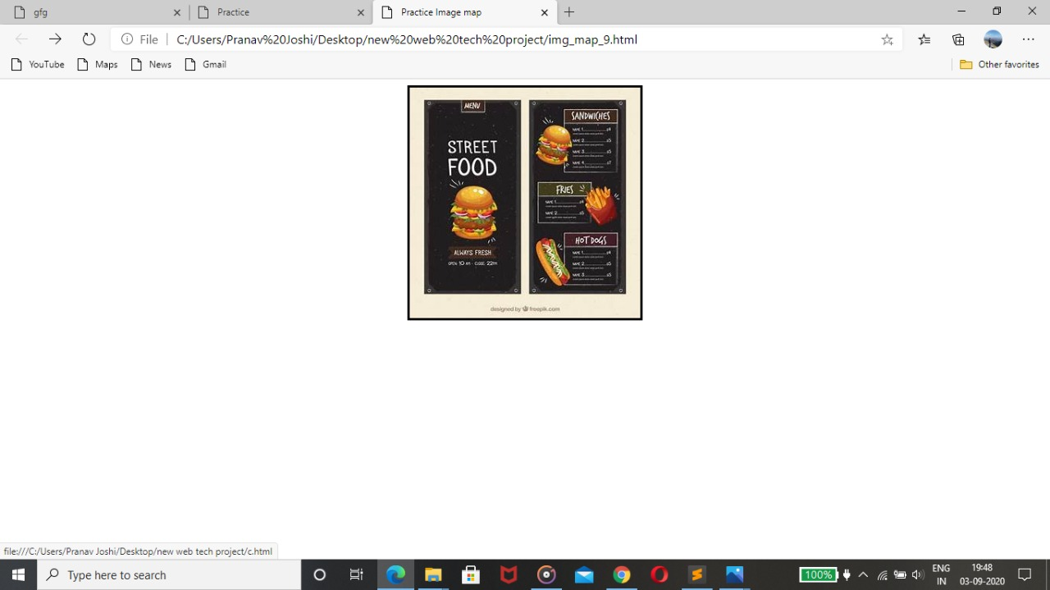

NAME – NIKITA BISHT

COURSE – BCA 5b

ROLL NO – 13

UNIVERSITY ROLL NO – 1121093

**Date- 0**1/09/2020

**PROBLEM STATEMENT -10:**

Write a HTML code to create a web page with four frames.

**OBJECTIVE:**

To understand the concept of frames in HTML.

**DESCRIPTION :**

The <frame> tag was used in HTML 4 to define one particular window (frame) within a <frameset>.

**HTML CODE:**

<!DOCTYPE html>

<html>

<head>

<title>HTML Frames</title>

</head>

<frameset rows = "50%,50%,50%,50%">

<frame name = "top"src = "c.html">

<frame name = "main"src = "d.html">

<frame name = "bottom"src = "table.html">

<frame name = "bottom"src = "test.html">

<noframes

<body>Your browser does not support frames.</body>

</noframes>

</frameset>

</html>

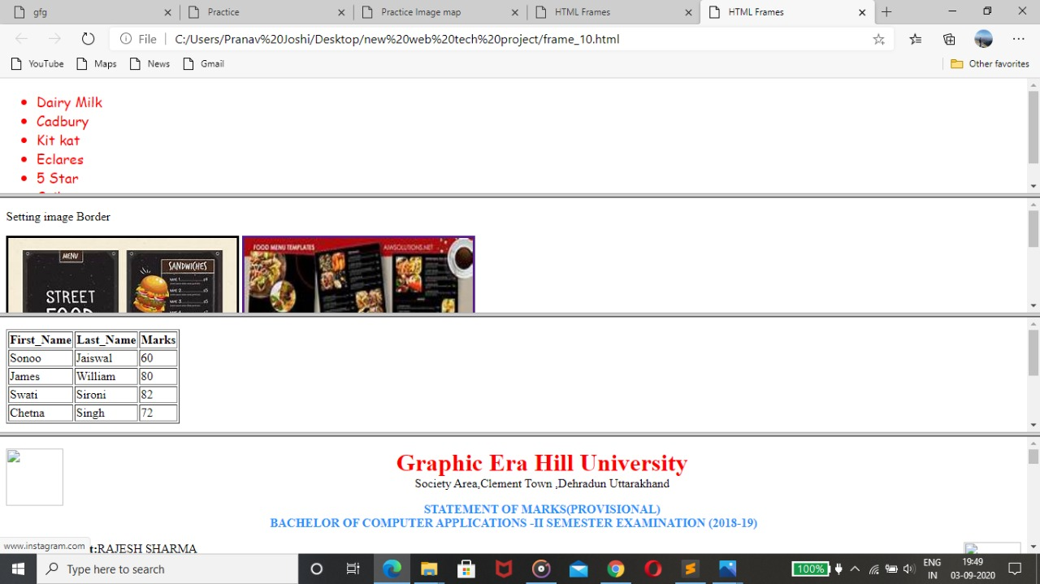

NAME – NIKITA BISHT

COURSE – BCA 5B

ROLL NO – 13

UNIVERSITY ROLL NO – 1121093

**PROBLEM STATEMENT -11:**

Write a HTML program to demonstrate the use of following tags.

i. DIV                             ii. SPAN

**OBJECTIVE:**

To understand the use of DIV and SPAN tag.

**DESCRIPTION :**

The div tag is known as Division tag. The div tag is used in HTML to make divisions of content in the web page like (text, images, header, footer, navigation bar, etc).

The HTML span element is a generic inline container for inline elements and content. It used to group elements for styling purposes (by using the class or id attributes).

**HTML CODE:**

<html>

<head>

<title>gfg</title>

<style>

.clss{

text-align: center;

background-color:#424242;

color:white;

height: 400px;

width:400px;

margin-left: 450px;

margin-top: 75px;

}

</style>

</head>

<body>

<div class="clss">

<form>

<legend><font color="red" size="10"><b>Instagram</b></font></legend><br><br><br>

<input type="text" name="name" placeholder="Phone Number or Username"><br><br>

<input type="Password" name="pass" placeholder="Password"><br><br>

<input type="submit" value="Log In"><br><br>

-----------OR----------<br><br>

<span style="background-color:blue;"><u> Log In with FaceBook</u></span><br><br>

Forgot Password?<br><br>

<span style="background-color:red;">Dont't have an account?<font color="blue "><b>Sign up</b></font></span><br><br>

</form></div>

</body>

</html>

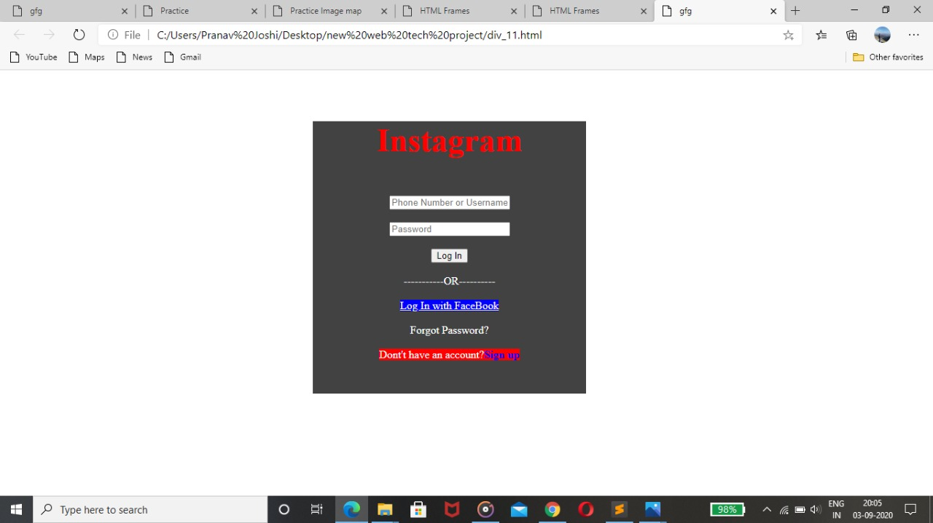

NAME – NIKITA BISHT

COURSE – BCA 5b

ROLL NO – 13

**PROBLEM STATEMENT -12:**

Demonstrate all the type of CSS with the help of an example.

**OBJECTIVE:**

To understand the use of CSS in creating web pages.

**DESCRIPTION :**

An inline CSS is used to apply a unique style to a single HTML element.

An inline CSS uses the style attribute of an HTML element**.**

CSS Font property is used to control the look of texts.

CSS Margin property is used to define the space around elements.

**HTML CODE:**

<!DOCTYPE html>

<html>

<head>

<link rel="stylesheet" type="text/css"href="css_type_12.css">

<style>

/*Internal CSS using element name*/

body{background-color:lavender;

text-align: center;}

h2{font-style: italic;

font-size: 30px;

color: #f08080;}

p{font-size: 20px;}

/*Internal CSS using class name*/

.green{color: green;}

</style>

</head>

<body>

<h2>Graphic Era Hill University</h2>

<h3 style="color: blue;

font-style: italic;

text-align: center;">Clement Town Dehradun,Uttarakhand</h3>

<p class="green">The Graphic Era Educational Society, established in 1993, is a non-profit organization that aims to mobilize world class education and generate resources for providing and supporting quality education for all. The society recognizes the right of every individual to lead a life of dignity and self-respect in a just and equitable manner. At the initial phase Graphic Era Society established in 1997 Graphic Era Institute of Technology. </p><br><br>

<h4>Graphic Era Institute of Technology had the distinction of being first Self- financed educational institute in North India, offer engineering courses The Institute was the culmination of the dream of its visionary founder Prof. (Dr) KamalGhanshala to change the destiny of thousands of youth by providing an excellent and holistic professional education.</h4><br><br>

<h5>He had visualized an educational hub that would cater to academic aspirations of innumerable young man and women and his vision took a concrete shape in the form of Graphic Era Institute.</h5>

</body>

</html>

h4{color:grey;

text-allign}

h5{

color:purple;

}

